BYLAWS FOR THE EAST COLFAX NEIGHBORHOOD ASSOCIATION

Articles of Incorporation signed August 9th, 1972; Certificate of Incorporation as a Colorado Nonprofit Corporation issued by Byron A. Anderson, Secretary of State, on August 15th, 1972.
Federal Tax I.D. (EIN) issued by the Internal Revenue Service as a nonprofit 501(c)(4) corporation: 23-7257740.
Mailing Address: P.O. Box 201273, Denver, CO 80220-1273.

Revised February 2020; approved MONTH/2020
Prior Bylaws Revised and approved March/April 1989.

ARTICLE I
NAME, LEGAL DESCRIPTION AND OBJECTIVE

SECTION 1. The East Colfax Neighborhood Association (ECNA) is the Registered Neighborhood Organization representing 11,000 residents and 113 businesses, schools or organizations in the East Colfax Neighborhood, found in the boundaries
to the north by Montview Boulevard and 23rd Avenue;
to the west by Quebec Street;
to the south by 11th Avenue;
to the east by Yosemite Street.
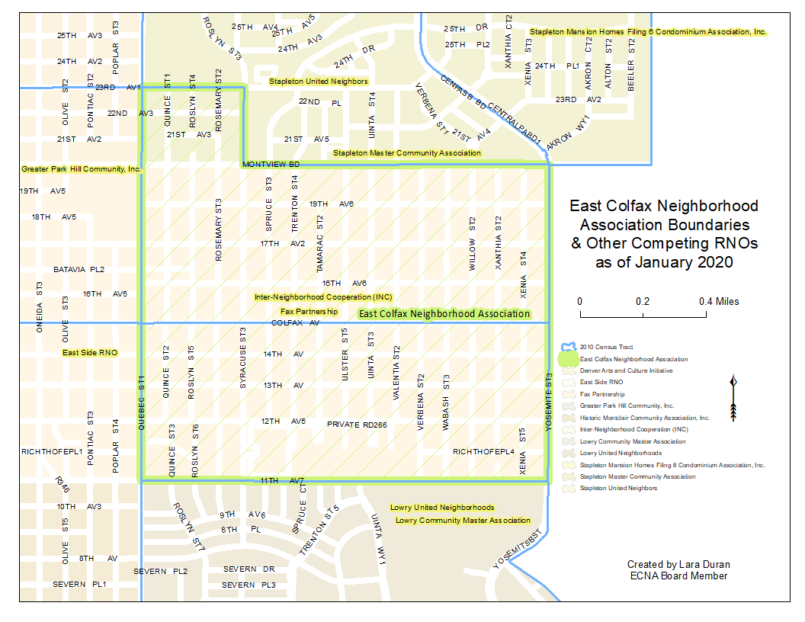

SECTION 2. The East Colfax Neighborhood Association exists to represent the people within the East Colfax Neighborhood herein referred to as East Colfax. In representing the fullest possible range of diversity in the East Colfax Neighborhood, the objectives of this organization are: the participation of all residents and business owners in the concerns most relevant to the neighborhood; to promote communication between East Colfax and the City and County of Denver; to promote communication between East Colfax and competing or complementary organizations and interests; to advance the interests and concerns of all within the neighborhood; and to elect representation and to encourage friendship and cooperation among all people within East Colfax. In 2019, ECNA declared anti-displacement as its top priority by unanimous vote.

ARTICLE II
MEMBERSHIP, DUES, DONATIONS AND GRANTS

SECTION 1. ELIGIBILITY. ECNA membership is open to all residents and business owners, with no exclusions based on age, income, language, ethnicity, or any other criteria.
- Membership only requires that someone express a desire to be a member to one of the Board Officers. The request for membership can be at any time of the year.
- The only requirement is that an individual live or own a business within the boundaries that the East Colfax Neighborhood Association by either providing their name, address within East Colfax, and an email address or some other version of contact information.
- Membership is at the individual level whether the individual is a resident or a business owner, school leader, or organization leader.

SECTION 2. DUES. The purpose of membership dues is to cover necessary operational expenses, unexpected expenses or as matching expenses.
- There are no membership dues, however the Board reserves the right to collect dues based on need. The need to collect and the amount of dues shall be determined by the Board Officers by a majority vote.
- Membership dues, if set, shall be due and payable on or before January 31st of each calendar year.
- Dues may be waived under circumstances as determined by the Board Officers.
- Dues shall never be a barrier to membership or used as such by ECNA.

SECTION 3. DONATIONS. The purpose of financial donations is to provide emergency financial assistance in the form of grants to East Colfax members.
- The ECNA may accept cash donations from any resident with a primary residence or business owner operating within the State of Colorado. Cash donations shall be deposited and managed in an accounting line separate from membership dues.
- The Board shall determine how donations are dispersed, the timeframe of grants, and the amounts by majority vote.
- Out-going grants awarded to East Colfax members shall be documented.

SECTION 4. GRANTS. The purpose of grants is to obtain and disperse funds to residents, make other neighborhood improvements or develop new neighborhood programs.
- The ECNA may apply for grant funding providing the source and use of funds is consistent with the objectives, priorities and policies of ECNA as determined by majority Board vote. If grants require in-kind or cash match, then the grant applications shall be approved by majority Board vote, and that reach majority general membership vote.
- Grant funds may be applied to or dispersed to residents, improvement projects or neighborhood programs that are consistent with the objectives, priorities and policies of ECNA as determined by majority Board vote, or that reach majority general membership vote.

ARTICLE III
GENERAL MEMBERSHIP MEETINGS

SECTION 1. The fiscal year of the Association shall be from January 1 through December 31.

SECTION 2. All meetings of the general membership shall be held once monthly on a date and at a time and place as designated by the Board. All meetings shall be open to all members and be held in a manner that facilitates accessible attendance. Meetings will be held outside of normal business hours, unless otherwise agreed to by a majority vote of the Board. General membership meetings may be held in-person or virtually.

SECTION 3. Special meetings of the general membership shall be called by a majority vote of the Board. Notification of such meetings shall state the nature of business and no other business shall be conducted.

SECTION 4. Special meetings of the Association must be called by the Board upon receipt of a written petition signed by ten (10) voting members.

SECTION 5. At least six (5%) percent of the general Members must be present to constitute a quorum at any general Member meeting and for general Member votes.

SECTION 6. No proxy votes by another person shall be permitted for general member ballots. General member votes may be cast in-person, by mail or and/or by electronic methods. Each member shall cast no more than one vote.

ARTICLE IV
ELECTION OF BOARD OFFICERS, TERMS OF OFFICE, DUTIES AND BOARD MEETINGS

SECTION 1. The ECNA shall be represented by an elected Board Officers of the Association, herein referred to as the Board, which shall be voted into office by a majority of general Members at the December meeting of each calendar year, and shall take office on January 1 of the following year.
- Votes for Board Officers may be cast in person, by mail or electronically.
- Votes for Board Officers shall not be by proxy by another person and may only be by Members.

SECTION 2. All Board Officers shall be nominated by the general membership.
- Nominations may be made from the floor by any ECNA member present at the time and date of the December election meeting.
- The Board Officers may select a nominating committee consisting of three members and one alternate. One committee member, but not more than one, shall be a member of the Board Officers. The committee shall submit a report of nominations to the membership at the October meeting and their report shall be published in the December Association newsletter.

SECTION 3. The Board Officers shall serve for a one-year term and may serve until their respective successors are elected. All officers may succeed themselves except the President who may not be elected to serve more than two successive terms.

SECTION 4. All Board Officers shall serve on a voluntary basis without pay, but shall be reimbursed for normal expenses incurred in the performance and scope of their duties.

SECTION 5. General management of the Association’s affairs shall be entrusted to the Board Officers. The President shall make a quarterly report to the general membership of actions taken by the Board Officers.

SECTION 6. BOARD OFFICERS. The Board shall be comprised of the President, Vice-President, Secretary, Treasurer, and six At-Large positions plus the Past President.
- The At-Large Board positions shall be reserved for under-represented residents with the sole purpose of ensuring that the Board represents the full diversity of the neighborhood in terms of culture, language, economic status, age, gender, sexual orientation and ability.
- Two At-Large Board positions may be filled by anyone in the neighborhood.
- Four At-Large Board positions shall be filled only by under-represented or under-served neighborhood members such as but not limited to residents of Ethiopian, Burmese, Latinx, Black Americans, Garden Court Apartments, Advenir Apartments, and Hope Communities / Hidden Brook Apartments residents.
- All Board Officers shall serve for one two-year terms.
- All Board Officers carry one Board vote, except the Past President, who shall serve only in a non-voting advisory capacity to the elected Board for one year.

SECTION 7. DUTIES OF THE BOARD OFFICERS. The Association’s elected Board officers shall serve in their respective capacities both with regard to the Association and its meetings and the Board and its meetings as follows.

- The President shall preside at all general member meetings of the Association and meetings of the Board and shall have the duties and powers normally pertinent to the office of President in addition to those particularly specified in these By-Laws. He or she shall have power to appoint such committees as may be necessary, subject to Board approval by majority vote. He or she shall represent the Association at all levels of community exposure, personally or through his or her appointed agent. He or she shall listen to all complaints and suggestions of the membership and bring such complaints and suggestions to the attention of the Board first, then if necessary to the general members of the Association in order that they may be acted upon for the improvement of the community. He or she shall supervise the bimonthly newsletter, but not necessarily edit it.
- The Vice-President shall exercise the powers and perform the duties of the President in case of the President’s death, absence, incapacity, resignation or removal.
- The Secretary shall record minutes of all meetings of the Association and the Board and of all matters of which a record shall be ordered by the Association. Minutes shall be posted on the ECNA website where they can be accessed by general members at will. He or she shall keep a roll of the members of the Association with their addresses and phone numbers or email addresses based upon information provided by the Treasurer, President or other Board Officer.
- The Treasurer shall collect and receive all monies due or belonging to the Association and shall deposit same in a separate managed account in a bank satisfactory to the Board in the name of the Association. The Treasurer shall make quarterly reports at the membership meetings, at the meetings of the Board and shall render an account of all monies received and expended during the fiscal year at the annual election meeting. The Treasurer shall document guidelines for incoming donations and grants and out-going grant awards, and track membership dues if collected and approved by majority vote of the Board.
- Officers shall attend Board meetings and general membership meetings. They shall have such other duties as may be directed by the President.

SECTION 8. BOARD OFFICERS MEETINGS.
Board meetings generally may be held once monthly as set by the President. Board meetings may be held in-person or virtually. Special meetings of the Board may be called by the President or Vice President.

SECTION 9. VACANCIES. Board Officer vacancies shall be filled with a Board-appointment, subject to ratification by a majority vote of the membership at the next scheduled membership meeting. Appointed Officers to vacant positions shall serve less than one-year term, not to exceed December 31st of any year. Should the office of President be vacated, the Vice-President automatically fills the vacancy and proceeds to fill the office of Vice-President as described in this Section.

SECTION 10. REMOVAL FROM OFFICE. In the event an elected officer or appointed member of the Board is unable or unwilling to perform the duties of his or her office, the Board, by majority vote, may request his or her resignation from that office through the Secretary. At the next regularly scheduled meeting of the Board, the Board, by unanimous vote, may declare the office vacant if the resignation is not received by the Secretary. The vacancy shall then be filled in accordance with the provisions of Article IV, Section 9.

SECTION 11. CONFLICT OF INTEREST. Conflicts of interests are those where decisions, outcomes or events that serve the personal or business owner interests of the Board Officer over those of the ECNA.
- Board Officers shall refrain from conflicts of interest. The Board Officer shall recuse themselves from votes or events where there is a perception of a conflict of interest. Any potential conflicts of interest on behalf of the Board Officers must be disclosed to the Board in a timely manner.
- The Board shall discuss and decided, upon majority vote, how to handle the perceived conflict. The Board decision shall include in the meeting minutes the nature of the conflict and how the conflict of interest was handled. If a Board Officer does not disclose potential conflicts of interest in a timely manner to the Board, the Board may pursue removal from office.

SECTION 12. BULLYING, DISCRIMINATION AND HARASSMENT. Bullying is any behavior that intimidates, controls, denigrates, threatens, abuses or coerces another person, often by someone with power, authority, position, or status to create a hostile environment that is repetitive. Discrimination is the unjust or preferential treatment of others based on age, cognitive or physical ability, ethnicity, color, race, religion, gender, sexual orientation, national origin, language, marital status, pregnancy, parenthood, immigration status, genetic makeup, or any classification or characteristic protected by state or federal law or regulation, or by this policy. Harassment is behavior that demeans, humiliates, embarrasses or other unwelcome conduct.

- ECNA prohibits, by all Board Officers and ECNA members, discrimination, harassment, or bullying based on protected classifications. ECNA further prohibits discrimination against a person perceived to have any of the above characteristics or against a person for associating with someone protected by this policy.

ARTICLE V
COMMITTEES

The President may appoint standing and special committees deemed necessary to promote the best interests of the neighborhood which the Association represents, subject to the approval of the Board.

ARTICLE VI
AMENDMENTS

The Articles of Incorporation and/or these By-Laws may be altered, amended, or repealed or new Articles or By-Laws adopted as hereby set forth. Such alteration, amendment, repeal or new Articles and/or By-Laws may be proposed by the Board to the general membership. Before a general membership vote on such change may be called for, it must be placed on an announced agenda and such change must be published in a newsletter, website, email and/or at the location where meetings are hosted at least two weeks prior to the meeting at which the vote will be taken.

ARTICLE VII
DISSOLUTION

In the event of ECNA dissolution or abandonment of duties by the President, Vice President, Secretary and Treasurer and no residents or business owner volunteers to assume leadership, all assets of the Association shall be donated to one or more of the non-profit organizations or schools within the East Colfax Neighborhood boundaries as a first priority, followed by non-profit organizations or schools within the 80220 zip code registered with the Colorado Secretary of State. Such dissolution must follow the procedure for dissolution provided by the Colorado Statutes.

ARTICLE VIII
ORDER OF BUSINESS

SECTION 1. At general membership meetings of the Association in which business is to be transacted, the order of business, so far as the character and nature of the meeting may permit, shall be as follows:
Minutes of the last meeting.
Report of the President.
Report of the Secretary.
Report of the Treasurer.
Report of Special Committees.
Election of Officers (annual meeting).
Unfinished Business.
New Business.
Adjournment.

SECTION 2. At meetings of the Board, the order of business, unless otherwise directed by majority vote of those present, shall be as follows:

Same as above, except substitute for Election of Officers:
Approval of President’s Appointments, if any.

ARTICLE IX
PARLIAMENTARY AUTHORITY

The rules contained in Roberts’ Rules of Order, Revised, shall inform the Association’s conduct of business in all cases to which they are applicable, and in which they are not inconsistent with the By-Laws of the Association.

ARTICLE X
GENERAL PROVISIONS

SECTION 1. The Association shall issue no capital stock and the rights and privileges of all members shall be equal. No loans shall be made in the name of the Association Any other loan is the personal responsibility of the person(s) making the loan. The financial books and records may be inspected by any member, or his(her) agent/attorney at a reasonable time and place.

SECTION 2. Except as otherwise provided, either in the Articles of Incorporation or in these By-Laws, which collectively take precedence in the event of an inconsistency, the Association shall operate under and by virtue of the provisions of the applicable Colorado Revised Statutes.

SECTION 3. These By-Laws replace and supercede all previously adopted By-Laws of this Association.

ARTICLE XI
PREVIOUS REVISIONS TO THE EMNA BY-LAWS

Due to the closure and development of the Lowry Air Force Base and the Stapleton Airport, two revisions were made. Both revisions were for the purpose of temporarily expanding our boundaries in order to receive notices from the City of proposed zoning changes adjacent to our neighborhood. These changes expired according to their nature and wording on October 24, 2004. They are attached to the 1989 Amended By-Laws for continuity and clarity only.

On October 24, 1994, the following wording was added to Section 1 which describes our boundaries:

“The southern boundary of EMNA will be expanded to 6th Avenue for a period of 10 years.”

The December 12, 2000, amendment temporarily expanded our northern boundary to 27th Avenue as follows:
“This organization shall be known as the East Montclair Neighborhood Association, Inc. whose temporary boundaries shall be Quebec Street through Yosemite Street and 6th Avenue through 27th Avenue until October 24, 2004, when the south boundary shall revert back to 11th Avenue and the north boundaries shall revert back to 23rd from Quebec to Syracuse and Montview Boulevard from Syracuse to Yosemite, unless further action is taken.”

